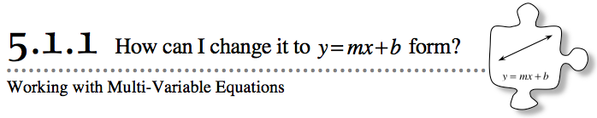
- So far in this course, you have used your Equation Mat and/or symbols to find solutions for all types of linear equations with one variable. Today you will learn how to apply these skills to solving linear equations with two variables.
- 5-1. You now have a lot of experience working with equations that compare two quantities. For example, while working with the height of a tree, you found the relationship y = 4x + 5, which compared x (the number of years after it was planted) with y (its height in feet). Use the equation for this tree to answer the questions below.
  - What was its starting height? How can you tell from the equation?
  - What was its growth rate? That is, how many feet did the tree grow per year? Justify your answer.
5-2. CHANGING FORMS
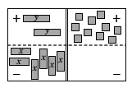
You can find the growth rate and starting value for y = 4x + 5 quickly, because the equation is in y = mx + b form. But what if the equation is in a different form?
  - The line −6x + 2y = 10 is written in standard form. Can you tell what the growth rate of the line is? Its y-intercept? Predict these values.
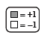
  - The equation −6x + 2y = 10 is shown on the Equation Mat at right. Set up this equation on your Equation Mat using tiles. Using only “legal” moves, rearrange the tiles to get y by itself on the left side of the mat. Record each of your moves algebraically.
  - Now use your result from part (b) to find the growth factor and y-intercept of the line −6x + 2y = 10. Did your result match your prediction in part (a)?

5-3. Your teacher will assign you one of the linear equations listed below. For your equation:
  - Use algebra tiles to set up the equation on your Equation Mat.
  - Using only “legal” moves, rearrange your tiles to create an equation that starts with “y = …” Be sure to record all of your moves algebraically and be prepared to share your steps with the class.
  - What is the growth factor of your line? What is the y-intercept? How can you tell?
- 2x + y = 3x − 7
- x + 2y = 3x + 4
- 3y + 2 = 2y − 5x
- 2(y − 3) = 2x − 6
- 5 − 3(x + 1) = 2y − 3x + 2
- x − (y + 2) = 2(2x + 1)
5-4. Solve each of the following equations for the indicated variable. Use your Equation Mat if it is helpful. Write down each of your steps algebraically.
  - Solve for y: 2(y − 3) = 4
  - Solve for x: 2x + 5y = 10
  - Solve for y: 6x + 3y = 4y + 11
  - Solve for x: 3(2x + 4) = 2 + 6x + 10
  - Solve for x: y = −3x + 6
  - Solve for p: m = 8 − 2(p − m)
  - Solve for q: 4(q − 8) = 7q + 5
  - Solve for y: x² + 4y = 2(3x − 6 − x) + x²

