Name:
Date:
Lesson 5.1.1 Homework
- 5-5. A tile pattern has 5 tiles in Figure 0 and adds 7 tiles in each new figure. Write the equation of the line that represents the growth of this pattern.

- 5-6. Solve each equation below for the indicated variable, if possible. Show all steps.
  - Solve for x: 2x + 22 = 12

  - Solve for y: 2x − y = 3

  - Solve for x: 2x + 15 = 2x – 15

  - Solve for y: 6x + 2y = 10

5-7. Solve each of the following equations for x. Then check each solution.

5-8. Graph the lines y = −4x + 3 and y = x − 7 on the same set of axes. Then find their point of intersection.
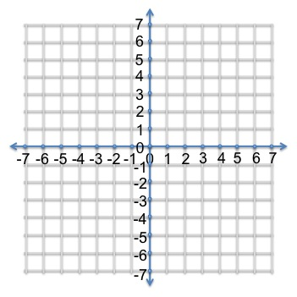

5-9. Draw Figures 1, 2, and 3 for a tile pattern that could be described by y = −3x + 10.

