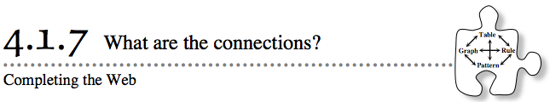
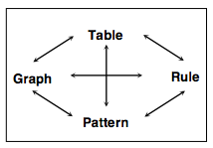
- After all of the work you have done with equations in y = mx + b form, you know a lot about starting with one representation of a pattern and moving to different representations. Today you will work with your team to make sure you are confident moving around the Representations of Patterns Web.
- Answer problems 4-64 and 4-65 on graph paper. Discuss each problem with your team to get as much as you can out of these problems.
- 4-64. GRAPH → PATTERN and TABLE → PATTERN
- On graph paper, draw tile patterns (Figures 0, 1, and 2) that could represent the data shown below. Be creative, but make sure that the growth of each pattern makes sense to your teammates.
  - 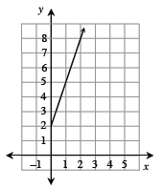
  - 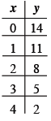

4-65. REVISITING “GROWING, GROWING, GROWING”
Problem 1-10 from Chapter 1 asked you to determine which figure in the pattern shown below would have 79 tiles. Now that you know more about tile patterns, x → y tables, graphs, and rules, you can show the answer to this question in multiple ways.
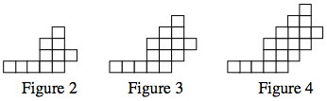

Your Task: Solve this problem by completing the following tasks. Use a graphing calculator or other graphing technology to help you find a graph and a table. Be sure to record your work and justify your thinking.
  - Copy the three figures above onto a piece of graph paper. On your graph paper, extend the pattern to include Figures 1 and 5.
  - Find a table, a graph, and a rule, for this pattern.
  - Which figure will have 79 tiles? Use as many representations as you can to justify your answer.

