Name:
Date:
Lesson 4.1.7 Homework
- 4-67. Use what you know about m and b to graph each equation below without making a table. Show a growth triangle on each graph and label the x- and y-intercepts.
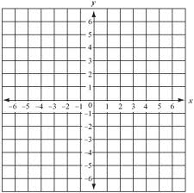
  - y = 3 − 2x
  - y = 2x
  - y = 3
  - y = −x + 3

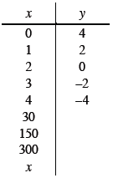
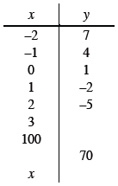
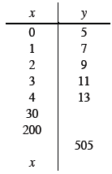
4-68. Complete each x → y table below. Using what you know about m and b, write an equation that represents the data in the table.

4-69. For a tile pattern with the rule y = 6x + 4 (where x represents the figure number and y represents the number of tiles), which figure number has 40 tiles in it? How do you know?

4-70. Josie and Jules are building a model car. They find that the real car is 54 inches tall and 180 inches long. They decide to make their model 3 inches tall, but now they are having a disagreement. Josie thinks that their model should be 10 inches long and Jules thinks it should be 129 inches long. Help them settle their argument by deciding if either of them is correct. Explain how you know exactly how long their model should be.

4-71. This problem is a checkpoint for area and perimeter of circles and complex figures. It will be referred to as Checkpoint 4.
Find the area and perimeter or circumference of each figure.
  - Circle with radius 3 cm.

  - Circle with diameter 10 feet.

  - Only the shaded region (each sector has equal area).

   