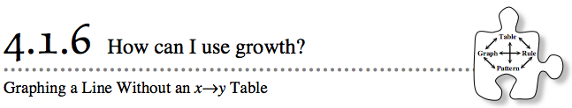
- You have now used your knowledge of growth factors and Figure 0 to create tile patterns and x → y tables directly from rules. You have also looked at graphs to determine the equation or rule for the pattern. Today you will reverse that process and use an equation to create a graph without the intermediate step of creating an x → y table.
- 4-54. For each of the graphs below:
  - Write a rule.
  - Describe how the pattern changes and how many tiles are in Figure 0.

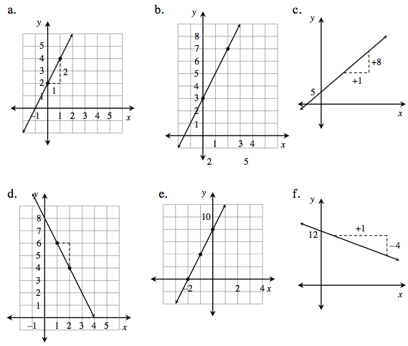
4-55. Now reverse the process. Graph the following rules without first making a table. Parts (a) and (b) can go on the same set of axes, as can parts (c) and (d). Label each line with its equation, y-intercept (where it crosses the y-axis), and a growth triangle.
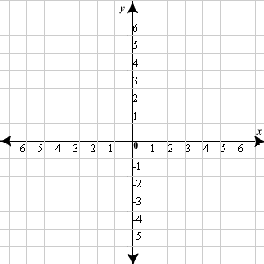
  - y = 4x + 3 b. y = 3x

c. y = −3x + 8 d. y = x – 1

- 4-56. Sketch a graph that fits each description below and then label each line with its equation. You can put all of the graphs on one set of axes if you label the lines clearly. Use what you know about growth factor and Figure 0 to help you.
  - A pattern that has three tiles in Figure 0 and adds four tiles in each new figure.

  - A pattern that shrinks by three tiles between figures and starts with five tiles in Figure 0.

  - A pattern that has two tiles in all figures.

