Name:
Date:
Lesson 4.1.6 Homework
- 4-59. Use what you know about m and b to graph each rule below without making a table. Draw a growth triangle for each line.

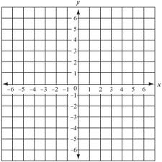
  - y = 2x – 3
  - y = −2x + 5
  - y = 3x
  - y = $\frac{1}{2}$x + 1

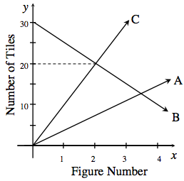
4-60. Examine the graph below, which displays three tile patterns.
  - What do you know about Figure 0 for each of the three patterns?

  - Which pattern changes most quickly? How quickly does it change? Show how you know.

  - Which figure number has the same number of tiles in patterns B and C? Explain how you know.

  - Write a rule for pattern B.

4-61. Translate these algebraic statements into words: y = 2x + 5 and y = 6x + 5.
  - What do you know about Figure 0 for each pattern?

  - Which pattern grows most quickly? How do you know?

4-62. Find the area and perimeter of each shape. Show your work.
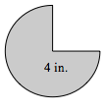
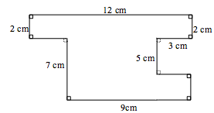

4-63. Ms. B is making snickerdoodle cookies. Her recipe uses one-and-a-half teaspoons of cinnamon to make two-dozen cookies. If she needs to make thirteen-dozen cookies to give one cookie to each of her students, how much cinnamon will she need? There are three teaspoons in one tablespoon. How many tablespoons and teaspoons will Ms. B need?

