Name:
Date:
Lesson 4.1.5 (Part 2) Homework
4-49. Invent a tile pattern that grows by 4 each time. Draw Figures 0, 1, 2, and 3. Use color or shading to show the growth.

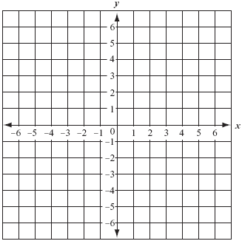
4-50. Complete a table for the rule y = 3 − x.
  - Draw a complete graph for this rule.

  - Is (32, −29) a point on this graph? Explain why or why not.

4-51. For each equation below, solve for the variable. Check your solutions, if possible, and show all work.

  - 3p − 7 + 9 − 2p = p + 2, solve for p

  - −2x + 5 + (−x) − 5 = 0, solve for x

  - 12 = r + 6 − 2r, solve for r.

  - −(y² − 2) = y² − 5 − 2y², solve for y

4-52. Solve each equation below for x. Then check your solutions.

4-53. Sketch a graph to match each story below using axes labeled as shown at right.
  - Luis rides his skateboard at the same speed all the way home. It takes him ten minutes to get there.
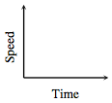

  - Corinna jogs along at the same speed until she reaches a hill, and then she slows down until she finally stops to rest.

  - Sergei is talking with his friends at the donut shop when he realizes that it is almost time for math class. He runs toward school, but he slows to a walk when he hears the bell ring and realizes that he is already late. He sits down in class four minutes after he left the donut shop.

