Name:
Date:
Lesson 4.1.5 (Part 1) Homework
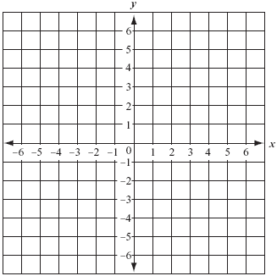
- 4-44. Complete a table for the rule y = 3x − 2.
  - Draw a complete graph for this rule.

  - Is (−50, −152) a point on the graph? Explain how you know.

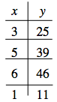
4-45. Write down everything you know about the tile pattern represented by the x → y table at right. Be as specific as possible.

4-46. Find the area and circumference of a circle that has a diameter of 17 mm. Write your answers in terms of π and as a decimal approximation.

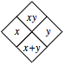
4-47. Copy and complete each of the Diamond Problems below. The pattern used in the Diamond Problems is shown at right.
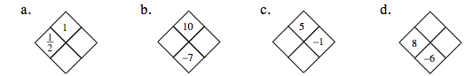
4-48. Simplify each of the expressions below. You may use an Equation Mat and tiles.

  - −(5x + 1)

  - 6x − (−5x + 1)

  - −(1 − 5x)

  - −5x + (x − 1)

