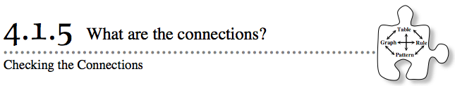
- In the last several lessons, you have been finding connections and relationships between different representations of patterns. You have worked backward and forward. You have also used information about Figure 0 (or the starting point) and the growth factor to write rules. In today’s activity, you will use pieces of information from various parts of the web to generate a complete pattern.

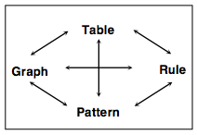
- 4-42. CHECKING THE CONNECTIONS: TEAM CHALLENGE
- Today you are going to apply what you know about the starting point (Figure 0), the growth factor, and the connections between representations to answer some challenging questions. The information in each question, parts (a) through (d), describes a different pattern. The graph of each pattern is a line. From this information, generate the rule, x → y table, graph, and tile pattern (Figures 0 through 3) that follow the pattern. You may answer these questions in any order, but make sure you answer each one completely before starting another problem.
- Work together as a team. The more you listen to how other people see the connections and the more you share your own ideas, the more you will know at the end of the lesson. Stick together and be sure to talk through every idea.
- Each person will turn in his or her own paper at the end of this activity, showing four complete representations for each pattern. Your work does not need to be identical to your teammates’ work, but you should have talked and agreed that all explanations are correct.

  - 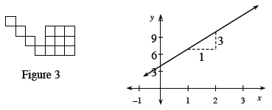
  - 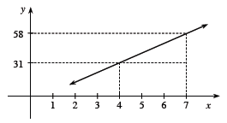
  - 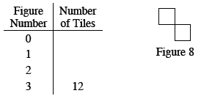
  - y = −3x + 7 