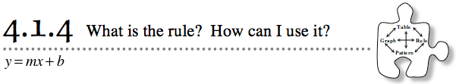
- In Lessons 4.1.2 and 4.1.3, you investigated connections between tile patterns, x → y tables, graphs, and rules (equations). Today you will use your observations about growth and Figure 0 to write rules for linear patterns and to create new tile patterns for given rules.
- 4-30. With your team, list some of the equations you have been working with in the past two lessons. What do all of these rules have in common?
- 4-31. UNDERSTANDING y = mx + b
- Rules for linear patterns can all be written in the form y = mx + b.
- In y = mx + b , x and y represent variables, while m and b represent parameters. Parameters are numbers that stay the same in the equation after they are chosen. Discuss these questions with your team:
  - What does m tell you about the pattern?
  - What does b tell you about the pattern?
4-32. GRAPH → RULE
Allysha claims she can find the equation of a line by its graph without using a table. How is that possible? Discuss this idea with your team and then try to find the equation of the line at right without first making a table. Be ready to share with the class how you found the rule.
4-33. TABLE → RULE
Allysha wonders if she can use the idea of m and b to find the equation of a line from its table.
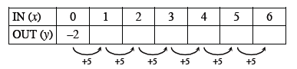
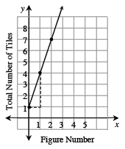
  - For example, if she knows the information about a linear pattern given in the table below, how can she find the equation of the line? Work with your team to complete the table and find the rule.

  - Use this same idea to find the rule of the linear tile patterns represented by the tables below.
    - 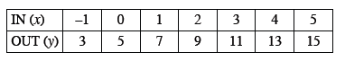
    - 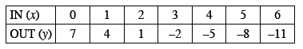
  - Write a summary statement explaining how you used your knowledge about m and b to quickly write a rule.
4-34. RULE → PATTERN
In each problem below, invent your own pattern that meets the stated conditions.
  - Draw Figures 0, 1, 2, and 3 for a tile pattern that has y = 4x + 3 as a rule.

  - A tile pattern decreases by 2 tiles. Figure 2 of the pattern has 8 tiles. Draw Figures 0, 1, 2, and 3 and write the rule (equation) for the pattern.

4-35. Invent two different tile patterns that grow by 4 every time but have different
x → y tables. Draw Figures 0, 1, 2, and 3 and find rules for each of your patterns. What is different about your rules? What is the same?

