Name:
Date:
Lesson 4.1.4 Homework
- 4-37. Examine the x → y table at right.
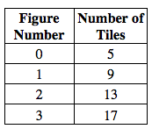
  - Invent a tile pattern that fits this data.

  - What is the pattern’s growth factor? Show where the growth factor appears in the x → y table and the tile pattern.

  - Write a rule for this pattern.

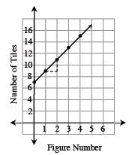
4-38. Look at the graph at right. What statements can you make about the tile pattern the graph represents? How many tiles are in Figure 0? Figure 1? What is the growth factor? What is the rule for the pattern?

4-39. For each equation below, solve for x. Check your solution, if possible, and show all work.

  - 3x − 6 + 1 = − 2x − 5 + 5x

  - −2x − 5 = 2 − 4x − (x − 1)

4-40. I am thinking of a number. When I double my number and then subtract the result from five, I get negative one. What is my number? Write and solve an equation.

4-41. Use your pattern skills to complete the table.
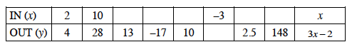
  - Explain in words what is done to the input value, x, to produce the output value, y.

  - Explain the process you used to find the missing input values.

