Name:
Date:
Lesson 4.1.3 Homework
- 4-25. Two of the connections in your Representations of Patterns Web are pattern → table and pattern → rule. Practice these connections as you answer the questions below.
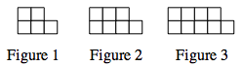
  - Draw Figure 0 and Figure 4 for the pattern at right.

  - Represent the number of tiles in each figure with a table.

  - Represent the number of tiles in each figure with an algebraic rule.

4-26. Use the formula for the area of a circle to solve for the radius of the circle if the area is 78.5 cm².

4-27. For each of the equations below, solve for x. Show all work and check your solution.

  - −2 + 2x = −x + 2 + x

  - 2 − 3x = x + 2

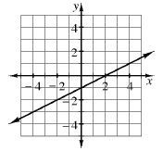
4-28. Another one of the connections in your Representations of Patterns Web is graph → table. In Chapters 1 through 3, you developed tools to find a table from a graph. Consider this connection as you complete the table below. The table is based on the graph at right.
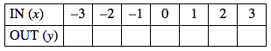

4-29. Joe drove 100 miles from San Francisco to Gilroy and used 4 gallons of gas. How much gas should he expect to use for a 3000-mile trip to New York City? What is the unit rate (miles per gallon)? Be sure to justify your reasoning.

