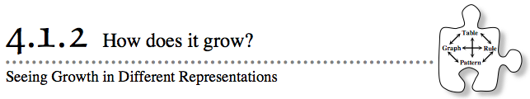
- In Lesson 4.1.1, you looked at four different ways of representing patterns and began to find connections between them.
- Throughout this chapter, you will explore connections between and find efficient ways to move from one type of representation to another. Today, you will look for specific connections between geometric patterns and equations. As you work, keep these questions in mind:
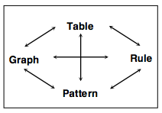
- How can you see growth in the rule?
- How do you know your rule is correct?
- What does the representation tell you?
- What are the connections between the representations?
- At the end of this lesson, put your work from today in a safe place. You will need to use it during Lesson 4.1.3.
- 4-12. Tile Pattern #1:
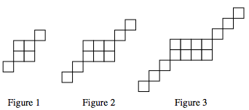
- Examine the tile pattern shown below and on the Lesson 4.1.2 Resource Page that your teacher gives you.

  - What do you notice? After everyone has had a moment to examine the figures independently, discuss what you see with your team.
  - Sketch the next figure in the sequence (Figure 4) on your resource page. Sketch Figure 0, which is the figure that comes before Figure 1.
  - How is the tile pattern growing? Where are the tiles being added with each new figure? On your resource page, use a marker or colored pencil to color in the new tiles in each figure.
  - What would Figure 100 look like? Describe it in words. How many tiles would be in the 100th figure? Find as many ways as you can to justify your conclusion.
- 4-13. For each of the patterns below, answer questions (a) through (d) from problem 4-12. Use color to shade in the new tiles on each pattern on your resource page. Choose one color for the new tiles in part (a) and a different color for the new tiles in part (b).
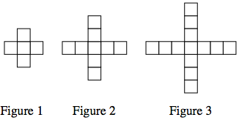
  - Tile Pattern #2:

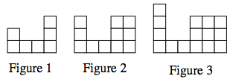
  - Tile Pattern #3:

4-14. PUTTING IT TOGETHER
Look back at the three different tile patterns in problems 4-12 and 4-13 to answer the following questions.
  - When you compare these three patterns, what is the same and what is different? Explain in a few sentences.
  - Find an equation (rule) for the number of tiles in each pattern. Label each tile pattern on your resource page with its rule.
  - What connections do you see between your equations and the tile pattern? Show and explain these connections.
  - Imagine that the team next to you created a new tile pattern that grows in the same way as the ones you have just worked with, but they refused to show it to you. What other information would you need to be able to predict the number of tiles in Figure 100? Explain your reasoning.

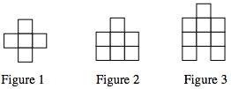
- 4-15. Consider Tile Pattern #4, shown below.
  - Draw Figures 0 and 4 on the resource page.
  - Find an equation (rule) for the number of tiles in this pattern. On your resource page, label Tile Pattern #4 with its rule. Then use a new color to show where the numbers in your rule appear in the tile pattern.
  - What is the same about this pattern and Tile Pattern #3? What is different? What do those similarities and differences look like in the tile pattern? In the equation?
  - The growth factor is the number of tiles by which the pattern increases each time you move from one figure to the next figure in the sequence. How is the growth factor represented in each equation?

