Name:
Date:
Lesson 4.1.2 Homework
- 4-17. Simplify each of the following equations and solve for x. Show all work and check your solution.

  - 7 − 3x = −x + 1

  - −2 + 3x = −(x + 6)

4-18. Leala can write a 500-word essay in an hour. If she writes an essay in 10 minutes, approximately how many words do you think the essay contains?

4-19. Complete the table below.
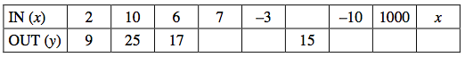
  - Explain in words what is done to the input value (x) to produce the output value (y).

  - Write the rule you described in part (a) with algebraic symbols.

4-20. When Susan’s brother went to college, she and her two sisters evenly divided his belongings. Among his possessions were 3 posters, 216 books, and 24 CDs. How were these items divided?

4-21. Kelso’s mom wants to put a floating blanket over the family’s circular wading pool to keep the heat in and the leaves out. The pool has a diameter of 10 feet.
  - How many square feet of blanket will Kelso’s mother need?

  - If the pool supply store charges $0.10 per square foot for the blanket, how much will the material for the blanket cost?

