Name:
Date:
Lesson 4.1.1 (Part 2) Homework
- 4-7. Make an x → y table for the rule y = x² − 2x.
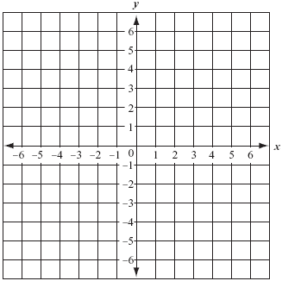
  - Plot and connect the points on a complete graph.

  - Does your graph look like a full parabola? If not, add more points to your table and graph to complete the picture.

4-8. THE GAME SHOW
Susan had an incredible streak of good fortune as a guest on an exciting game show called “The Math Is Right.” She amassed winnings of $12,500, a sports car, two round-trip airline tickets, and five pieces of furniture.
In an amazing finish, Susan then landed on a “Double Your Prize” square and answered the corresponding math question correctly. She instantly became the show’s biggest winner ever, earning twice the amounts of all her previous prizes.
A week later, $25,000, a sports car, four round-trip airline tickets, and five pieces of furniture arrived at her house. Susan felt cheated. What was wrong?

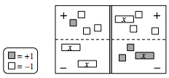
4-9. Write the equation represented by the diagram at right.
  - Simplify as much as possible and then solve for x.

  - Check your solution.

4-10. Simplify the following expressions by combining like terms.

  - y + 3x − 3 + 2x² + 8x − 5y

  - 2x + 4x² − 6x ² − 9 + 1 − x − 3x

  - 14 + 3y² + 30y − 3y² - 14y − 14 + 16y

  - −10 + 13y − 6x + 5y² + 10y − 5y²

4-11. Use your pattern-finding techniques to fill in the missing entries for the table below. Then find a rule for the pattern.
