Name:
Date:
Lesson 4.1.1 (Part 1) Homework
- 4-2. For each tile pattern in problem 4-1, draw Figures 0, 4, and 5.
a. b.

c. d.

e.

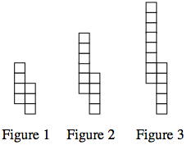
4-3. Draw Figure 0 and Figure 4 for the pattern at right.

  - Represent the number of tiles in each figure in an x → y table. Let x be the figure number and y be the total number of tiles.

  - Use the table to graph the pattern.

  - Without drawing Figure 5, predict where its point would lie on the graph. Justify your prediction.

4-4. Evaluate the expressions below for the given values.

  - 3(2x + 1) for x = −8

  - $\frac{x-6}{4}-1$ for x = −14

  - −2m² + 10 for m = −6

  - k · k ÷ k · k ÷ k for k = 9

4-5. Copy and simplify the following expressions by combining like terms.

  - x + 3x − 3 + 2x² + 8 − 5x

  - 2x + 4y² − 6y² − 9 + 1 − x + 3x

  - 2x² + 30y − 3y² + 4xy − 14 – x

  - 20 + 3xy − 3xy + y² + 10 − y²

4-6. Use the Distributive Property to rewrite each expression.

  - 3(2x - 7)

  - –2(x − 7) + 5x

  - 5x + 10

  - 8x + 12y

