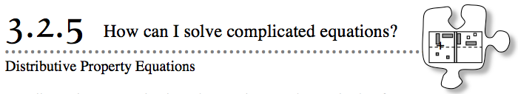
- Not all equations are as simple as the equations you have solved so far. However, many equations that look complicated just need to be broken into simpler, familiar parts. In this lesson, you will use algebra tiles to work with situations that combine addition and multiplication. Then you will solve equations that contain complicated parts.
- 3-107. So far in this course, you have solved single-variable equations like 3x + 7 = −x − 3. Consider this change to that equation: 3(x + 7) = −x − 3. What is different about the equations? How will the changes made to the original equation change the steps needed to solve the equation?
- 3-108. Use algebra tiles to build, draw, and simplify each expression.
  - 3(x + 4)
  - 4(2x − 1)
  - 2(x + 5) + 3
  - 3(x − 2) + 5
- 3-109. In a previous class, you used the Distributive Property to rewrite problems with parentheses similar to the ones above. Use the Distributive Property to complete and simplify each expression below. Read the Math Notes box at the end of this lesson if you need help getting started.
  - 2(x + 5) = 2 · x + 2 · 5 = 2x + ______
  - 3(2x + 1) = 3 · 2x + 3 · __ = ______
  - −2(x + 3) = −2 · __ + −2 · __ = ______
  - −3(2x − 5) = ______ = ______

3-110. Now use what you learned in the previous three problems to solve for x in the equation 3(x + 7) = −x − 3 . Show your steps and check your answer. You may want to use algebra tiles and an Equation Mat to help you visualize the equation.
3-111. Solve each of the following equations for x. Show your steps and check your answers.
  - 3x − 2(5x + 3) = 14 − 2x

  - 3(x + 1) − 8 = 14 − 2(3x − 4)

3-112. Earlier in this course, you learned that −(x − 3) was the same as −x + 3, because (x − 3) in the “−” region could be “flipped” to −x + 3 in the “+” region, as shown below.
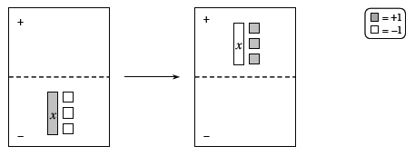
Use what you have learned in this lesson to explain algebraically why “flipping” works. That is, why does −(x − 3) = −x + 3?

