Name:
Date:
Lesson 3.2.5 Homework
- 3-113. Solve each equation.

  - 3(5x + 2) = 8x + 20

  - −2(x − 3) + 4x = −(−x + 1)

3-114. Simplify the following expressions.

  - x + 3x − 3 + 2x² + 8x – 5

  - 3y + 14y² − 6y² − 9y + 1 − y − 3y

  - 2y² + 30xy − 2y² + 4y − 4x

  - x − 0.2x

3-115. Louis recorded how many times he could jump rope without stopping. Here is his data:
50 15 102 64 29 55 100 97 48 81 61
Find the median, upper quartile, and lower quartile of his data. (hint: Box & Whisker)

3-116. Find the area and perimeter of the shape below. Show your work.
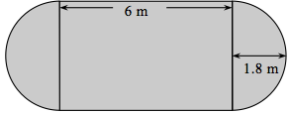

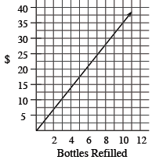
3-117. This problem is a checkpoint for unit rates and proportions. It will be referred to as Checkpoint 3.
In parts (a) through (c), use the given information to find the unit rate. In parts (d) through (f), write and solve a proportion based on the given information.

  - If 2$\frac{1}{4}$ pounds of bananas cost $1.89, what is the cost per pound?

  - What is the weight per cm?
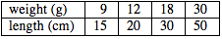

  - Use the graph to find the refill cost per bottle.

  - If 200 vitamins cost $4.75, what should 500 vitamins cost?

  - If a basketball player made 72 out of 85 free-throw attempts, how many could she expect to make in 200 attempts?

  - A cookie recipe uses $\frac{1}{2}$ teaspoon of vanilla with $\frac{3}{4}$ cup of flour. How much vanilla should be used with five cups of flour?

