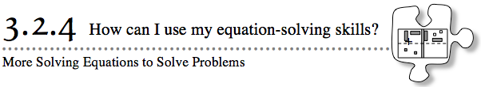
- In this section, you have solved many equations. Sometimes these equations were given to you. Other times they came from specific situations. You have begun to solve equations without using algebra tiles. In this lesson, you will continue to focus on how to show your work.
- 3-99. JOHN'S GIANT REDWOOD, Part Two
- In Lesson 3.1.2, you looked at how a tree increases in height as it gets older. Review the data below and, if possible, find your work from problem 3-10.
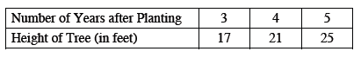
  - Assuming the tree continues to grow at a constant rate, find a rule for the height of the tree using x and y.
  - In your rule, what real-world quantity does x stand for? What real-world quantity does y stand for?
  - John wants to know how tall the tree will be when it is 20 years after planting. Use your rule to answer his question.
  - The tallest tree in the world, in Montgomery Woods State Reserve in California, is 367 feet high. John wants to know how long it would take for his tree to get that tall if it keeps growing at the same rate. Write and solve an equation you could use to answer John’s question. Be sure to check your solution.
  - Did you use algebra tiles to solve the equation in part (d)? Would it be easy to use algebra tiles to do so? Why or why not?

3-100. For the following equations, solve for the given variable. Record your work and check the solution, if possible.
  - 75c − 300 = 25c + 200
  - 26y − 4 − 11y = 15y + 6
  - −$\frac{1}{2}$x = 6
  - 0.8 − 2t = 1 − 3t
- 3-101. MR. WALLIS IS BACK!
- After much consideration, Mr. Wallis decided to use the tip table below to help him estimate what a 15% tip would be for various costs of dinner.
- 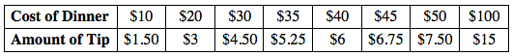
  - Find a rule for his table. That is, find a rule that calculates the amount of tip (y) based on the cost of the dinner (x). How did you find your rule?

  - After dinner, Mr. Wallis was so distracted that he forgot to write down the cost of the meal in his checkbook. All he remembers is that he left a $9 tip. What was the original cost of the meal before he paid the tip? Use your equation from part (a) to answer this question. Show all work.

  - What was the total cost of the meal including the tip?

