Name:
Date:
Lesson 3.2.4 Homework
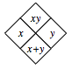
- 3-102. Copy and complete each of the Diamond Problems below. The pattern used in the Diamond Problems is shown at right.
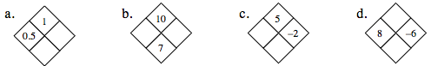
- 3-103. Joe is downloading songs from the Internet. He can download them at a rate of 8 songs every 10 minutes. Jasmine, who is also downloading songs, can download at a rate of 12 songs every 15 minutes. Who is downloading songs faster? What is the unit rate (songs per minute) for each person?

- 3-104. For the following equations, simplify and solve for the variable. Show all work and check your solution, if possible.

  - −2 + x = −x + 2

  - −(x − 1) = −4x – 2

  - 2 + 3x = 3x + 2

  - −(−x + 6) = −3x

3-105. Use your pattern-finding skills to copy and complete the table below.
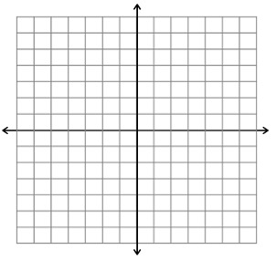
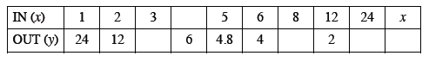
  - Explain the pattern you found in your table. How are x and y related?

  - Write the rule you described in part (a) with algebraic symbols.

  - Use the points in your table to graph this rule on graph paper. Describe the resulting shape.

3-106. Translate each algebraic expression into words.
  - 5x – 3

  - 2(x + y)

  - 3 − (x + 5)

