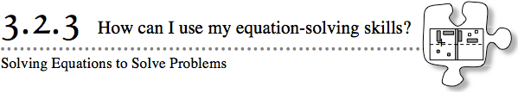
- In the last two lessons you have practiced solving equations. In this lesson you will apply your equation-solving skills to the patterns you found at the beginning of this chapter.
- 3-89. In Lesson 3.1.3, you investigated the “Big C’s” pattern of tiles, shown below. The rule you found for this pattern was y = 6x + 3, where x represented the figure number and y represented the number of tiles in the figure.
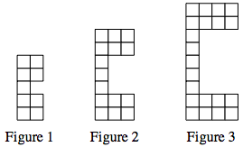
- Penelope wants to know how many tiles will be in Figure 50. How can you determine this? Write out in words what you would need to do with your rule to answer her question. Then answer Penelope’s question: How many tiles will be in Figure 50?
- 3-90. Lew wants to reverse the process. He says he has a “Big C’s” figure made up of 45 tiles and wants to know which figure number this pattern is.
  - In the rule y = 6x + 3, which variable must equal 45 to solve Lew's problem?
  - Write an equation you could use to solve Lew’s problem. Then solve your equation, recording all of your steps. Which “Big C’s” figure is made up of 45 tiles?
  - How can you check your answer to be sure it is correct? Check your solution.
3-91. Norm says he has a “Big C’s” pattern made up of 84 tiles. He wants to know which figure number this pattern is. Write and solve an equation as you did in problem 3-90. Does your solution make sense? Why or why not?

3-92. For the following equations, solve for x. Record your work and check your solution.
  - $\frac{1}{2}$x − 2 = x – 4

  - 8 − 0.25x = 0.5x + 2

  - x + 2 − 0.5x = 1 + 0.5x + 1

  - 7x − 0.15 = 2x + 0.6

3-93. Can an equation be solved using a graph? Consider this as you answer the questions below.
  - Solve the equation 5 = 1.6x + 1. Check your solution.

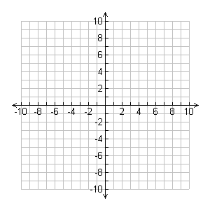
  - Complete a table for the rule y = 1.6x + 1. Then, on graph paper, graph the line.

  - Use the graph from part (b) to find x when y = 5. Did you get the same result as in part (a)?

