Name:
Date:
Lesson 3.2.3 Homework
- 3-94. For the following equations, solve for x. Check your solution, if possible. Record your work.

  - 3x − 7 = 3x + 1

  - −2x − 5 = −4x + 2

  - 2 + 3x = x + 2 + 2x

  - −(x − 2) = x + 2

3-95. Evaluate the expressions below for the given values.

  - 30 − 2x for x = −6

  - x² + 2x for x = − 3

  - $\frac{1}{2}$x + 9 for x = −6

  - for k = 9

3-96. The length of a rectangle is three centimeters more than twice the width. The perimeter is 78 centimeters. Define a variable and write and solve an equation to find out how long and how wide the rectangle is.

3-97. For the rule y = 4 − x², calculate the y-values that complete the table below. The first value is given for you.
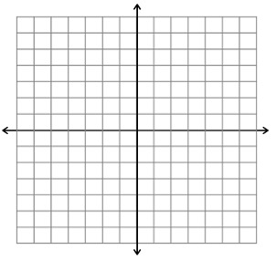
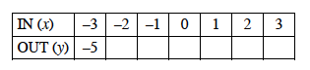
  - Create an x-axis and a y-axis and label your units. Plot and connect the points on your graph, and then label your graph with its rule.
  - What does your graph look like?

3-98. Simplify each expression.

