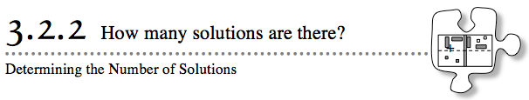
- In Lesson 3.2.1, you reviewed your equation-solving skills to remember how to find a solution to an equation. But do all equations have a solution? And how can you tell if an equation does not have a solution?
- Today you will continue to practice solving equations and will continue to investigate the meaning of a solution.
- 3-79. GUESS MY NUMBER
- Today you will play the “Guess My Number” game. Your teacher will think of a number and tell you some information about that number. You will try to figure out what your teacher’s number is, using paper and a pencil if needed. When you think you know what the mystery number is, sit silently and do not tell anyone else. This will give others a chance to think about it.
- 3-80. Use the process your teacher illustrated to analyze Game #3 of “Guess My Number” algebraically.
  - Start by writing an equation that expresses the information in the game.

  - Solve your equation, writing down each step as you go. When you reach a conclusion, discuss how it agrees with the answer for Game #3 you found as a class.

  - Repeat this process to analyze Game #4 algebraically.

3-81. How many solutions does each equation below have? To answer this question, solve these equations, recording all of your steps as you go along. Check your solution, if possible.
  - 4x − 5 = x − 5 + 3x
  - − x − 4x − 7 = −2x + 5
  - 3 + 5x − 4 − 7x = 2x − 4x + 1
  - 4x − (− 3x + 2) = 7x − 2
  - x + 3 + x + 3 = −(x + 4) + (3x − 2)
  - x − 5 − (2 − x) = −3
3-82. Create your own “Guess My Number” game like the ones you worked with in class today. Start it with, “I’m thinking of a number that…” Make sure it is a game for which you actually know the answer! Write the equation and solve it.

