Name:
Date:
Lesson 3.2.2 Homework
- 3-84. Draw Figure 0 and Figure 4 for the pattern below.
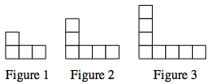

  - Represent the number of tiles in each figure with:
    - An x → y table.

    - An algebraic rule.

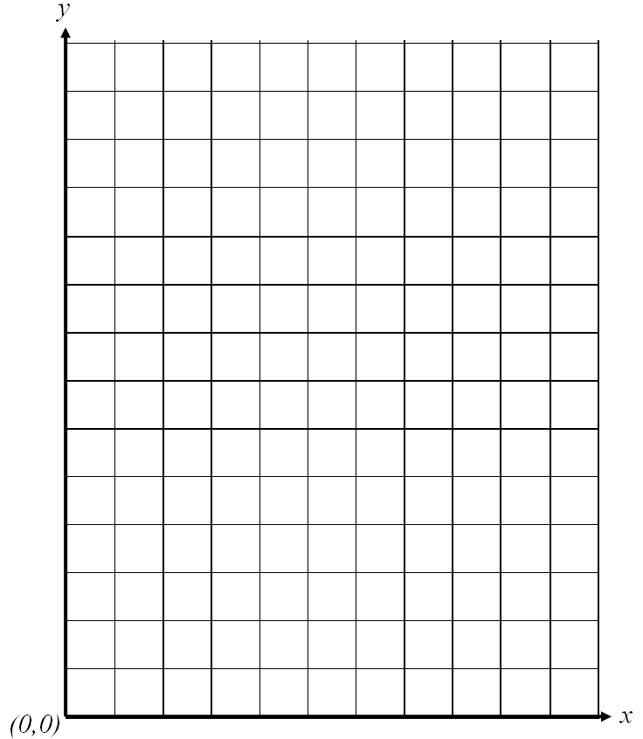
    - A graph.

  - Without drawing Figure 5, predict where its point would lie on the graph. Justify your prediction.

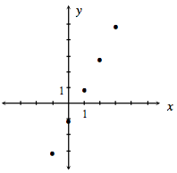
3-85. Examine the graph at right.
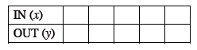
  - Use the graph to complete the table:

  - Use the graph to find the rule:
y = ____
3-86. Find the area and circumference of a circle with a diameter of 15 cm. If you need help remembering how to do this, read the Math Notes box in this lesson.

3-87. Simplify each of the following equations and solve for the variable. Show all work and check your solution, if possible.

  - 3x − 7 + 9 − 2x = x + 2

  - − 2m + 8 + m + 1 = 0

  - 2 = x + 6 − 2x

  - 0.5 p = p + 5

a. 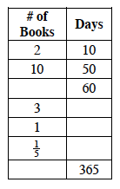 | b. 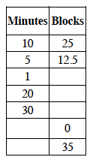 | c. 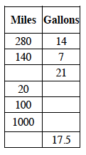
3-88. Mr. Wallis has done it again! He has started to create more tables to help him figure out things like how many gallons of gas it takes to travel a certain number of miles or how many minutes it takes to walk a certain number of blocks. Use proportional reasoning to complete his tables below.

