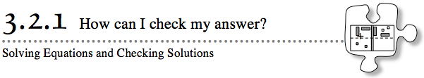
- In Section 2.2, you learned to solve equations on an Equation Mat. In this section, you will practice your equation-solving skills while adding a new element: You will check your answer to make sure it is correct.
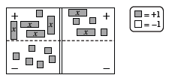
- 3-70. For this activity, share algebra tiles and an Equation Mat with your partner.
  - Start by setting up your Equation Mat as shown at right. Write the equation on your paper.
  - Next, solve the equation on your Equation Mat one step at a time. Every time you make a step, record your work in two ways:
    - Record the step that was taken to get from the old equation to the new equation.
    - Write a new equation that represents the tiles on the Equation Mat.
  - With your partner, find a way to check if your solution is correct.
3-71. WHAT IS A SOLUTION?
In this lesson you have found a solution to an algebraic equation. But what exactly is a solution? Answer each of these questions with your study team, but do not use algebra tiles. Be prepared to justify your answers!
  - Preston solved the equation 3x − 2 = 8 and got the solution x = 100. Is he correct? How do you know?
  - Edwin solved the equation 2x + 3 − x = 3x − 5 and got the solution x = 4. Is he correct? How do you know?
  - With your partner, discuss what you think a solution to an equation is. Write down a description of what you and your partner agree on.

3-72. Work with your partner to solve these equations, being careful to record your work. After solving each equation, be sure to check your solution, if possible.
  - 3x + 4 = x + 8

  - 4 − 2y = y + 10

  - 5x + 4 − 2x = −(x + 8)

  - −2 − 3k − 2 = −2k + 8 − k

3-73. IS THERE ANOTHER WAY?
Compare your solution to part (c) of problem 3-72 with the solution that another pair of students got. Did both solutions involve the same steps? Were the steps used in the same order? If not, copy the other pair’s solution onto your paper. If both pairs used the same steps in the same order to solve the equation, come up with a different way to solve the problem and record it on your paper.

