Name:
Date:
Lesson 3.2.1 Homework
- 3-74. For the following equations, solve for x. Be sure to check your answer, if possible. Show all work.

  - 3x + 7 = −x – 1

  - −3x = x − (6 − 2x)

  - Use a diagram of the Equation Mat or some other method to explain why −(x − 3) = −x + 3.

3-75. For each equation, a possible solution is given. Check to see if the given solution is correct.

  - If 3x + 7 = x − 1, then does x = −4?

  - If −2x − 4 = −4x + 3, then does x = 3?

  - If −3x + 5 + 5x − 1 = 0, then does x = 2?

  - If −(x − 1) = 4x − 5 − 3x, then does x = 3?

3-76. For the rule y = −2x + 1, calculate the y-values that complete the table below.
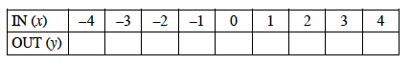
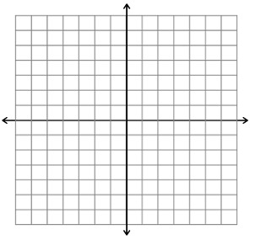
  - Graph your rule on a set of axes. Be sure to create a complete graph. If necessary, see the Math Notes box for this lesson to review what makes a graph complete.

  - Describe your resulting graph. What does your graph look like?

3-77. Simplify each expression below.

  - 4x + 7 + 3y − (1 + 3y + 2x)

  - 16x² − 4x + 5 − (16x² − 8x) + 1

  - (32x − 7y) − (28x − 11y)

  - y + 2 + 2y + 2 + 2y − 2x + y

3-78. Burgers-o-Rama is the best hamburger place in town. The owner, Ms. Hamm, buys two 5-pound packages of meat for $27.50. Use proportional reasoning to determine the information below. Be sure to explain your answer and organize your reasoning.
  - What should Ms. Hamm pay for 25 pounds of meat?

  - How many pounds can Ms. Hamm buy for $55.00?

