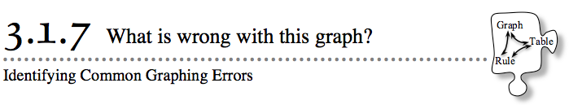
- In this chapter you have used rules to find y-values to go with x-values in tables. Then you graphed the x → y pairs you found. Today you will be examining how rules, tables, and graphs can be used to represent new situations. You will also learn how to avoid common graphing errors.
- 3-61. Ms. Cai’s class is studying the “dented square” shape shown at right. This shape is formed by removing a square with side length 1 from a larger square. Her students decided to let x represent the side length of the large square and y represent the perimeter of the entire shape.

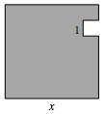
  - What is the perimeter of the “dented square?” That is, what rule could help you find the perimeter for any value of x?
  - Make a table for the rule you found. Make sure the x-values you use are appropriate for this situation. What are the possible x-values?
  - In this situation, x has a lower boundary value. This means that it must be greater than a specific value for the situation to make sense. Using what you know about writing inequalities, write an inequality statement for this limitation.
  - If you were to graph the inequality in part (c) on a number line, it would have an open circle. Why? How do you think this could be shown on a coordinate graph for this situation? Discuss this with your team and share your ideas with your class.
  - Do you think the points on your graph should be connected? Justify your answer.
  - Using what you decided in parts (d) and (e), make a graph from your x → y table.

3-62. GOOFY GRAPHING
Now Ms. Cai’s class is studying a tile pattern. Her students decided to represent the pattern with the x → y table at right.
  - Ms. Cai wants her class to graph the data in this table. Write (x, y) coordinates for each point that needs to be plotted.
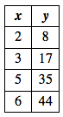
  - When Ms. Cai’s students started to graph this data, they made mistakes right from the beginning. The diagrams below show how some of Ms. Cai’s students set up their axes. Your teacher will assign your team one of these diagrams.
Your Task: Find all of the mistakes the students made in setting up the graph your teacher assigns you. (There may be more than one mistake in each graph!) Explain why this is an incorrect way to set up a graph, or why this is not the best way to set up the graph for this problem. Be ready to present your team’s ideas to the class.
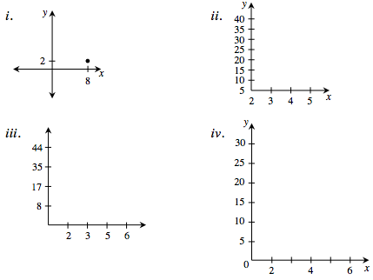

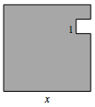
- 3-63. Sheila is in Ms. Cai’s class. She noticed that the graph of the perimeter for the “dented square” in problem 3-61 was a line. “I wonder what the graph of its area looks like,” she said to her teammates.

  - Write an equation for the area of the “dented square” if x represents the length of the large square and y represents the area of the square.
  - On graph paper, graph the rule you found for the area in part (a). Why does a 1st-quadrant graph make sense for this situation? Are there other values of x that cannot work in this situation? Be sure to include an indication of this on your graph, as necessary.
  - Explain to Sheila what the graph of the area looks like.
  - Use the graph to approximate x when the area of the shape is 20 square units.

