Name:
Date:
Lesson 3.1.7 Homework
- 3-65. ONE OF THESE POINTS IS NOT LIKE THE OTHERS, Part Two
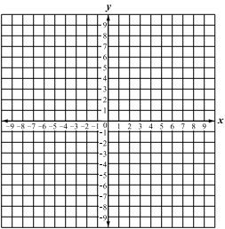
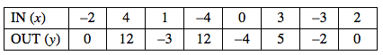
  - Plot and connect the points listed in the table below.

  - Identify the point that does not fit the pattern.

  - What shape does the graph appear to make?

  - Correct the point identified in part (b) so it fits the pattern. Write the points in (x, y) notation.

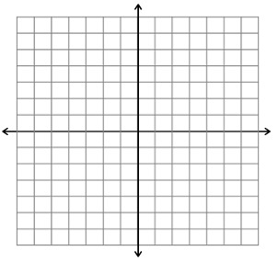
3-66. For each rule below, make a table of x- and y-values and then graph the rule on graph paper. Label each graph with its equation.

  - y = x²

  - y = −x²

  - Compare the graphs. What do you notice?

  - For the graph of y = x², estimate the x-values corresponding to y = 5.

  - For the graph of y = −x², estimate the x-values corresponding to y = −10.

3-67. The amount of money Theresa earns at her job varies directly with the number of hours she works. This means that her earnings are proportional with the time she works. She knows that when she works 2 hours, she earns $12. When she works 3 hours, she earns $18.
  - How much do you predict Theresa would earn after working 5 hours?

  - Use the unit rate to explain how can you find Theresa’s earnings (y) if she works for x hours.

  - Create a complete graph of Theresa’s earnings over time. Should the graph be continuous or discrete? Explain your decision.

3-68. Paris is trying to solve the equation 3x² − (2x − 4) = 3 + 3x² + 1. Her work is partially recorded below. Fill in her missing work to solve for x.
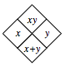
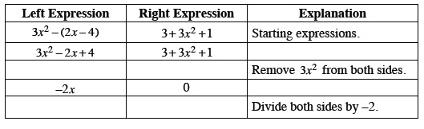
3-69. Copy and complete each of the Diamond Problems below. The pattern used in the Diamond Problems is shown at right.
