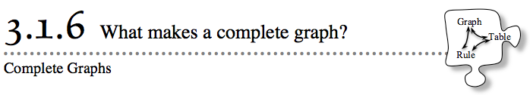
- Over the past several days, you have learned to make graphs from tables, then graphs from rules. Today you will continue to study graphs by deciding what needs to go into a graph to make it complete.
- 3-51. SILENT BOARD GAME
- Your teacher will put an incomplete x → y table on the board. Try to find the pattern (rule) that gets each y-value from its x-value. Find and write the rule for the pattern you find.
- 3-52. Examine the following graphs and answer the question associated with each one. What do you notice?
a. What are the coordinates of point A? | b. Where will the line be when x = 5? | c. What is t when k = 1?

- 3-53. Make your own complete graph for each of the following rules:
  - y = −x + 1

  - y = 0.5x + 2

  - y = x² – 4
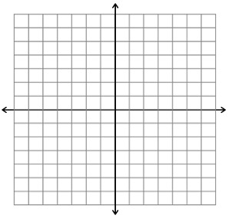
3-54. Examine the graphs from problem 3-53.
  - How are they different? Be as specific as you can.
  - Label the (x, y) coordinates on each of your graphs for the point where each graph crosses the y-axis. These points are called y-intercepts.
  - Label the (x, y) coordinates on each of your graphs for the point or points where each graph crosses the x-axis. These points are called x-intercepts.
3-55. LEARNING LOG
On your own graph paper, graph y = −3x + 2. Then, as a class, decide what needs to be included to make a graph complete. List the qualities of a complete graph

