Name:
Date:
Lesson 3.1.6 Homework
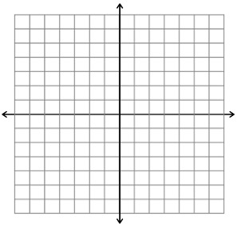
- 3-56. Complete a table for the rule y = x² + 2. Then plot and connect the points on a graph. Be sure to label the axes and include the scale. Use negative and positive values for x, as well as a value of 0.

- 3-57. Complete a table for the rule y = −x + 3. Then plot and connect the points on a graph. Be sure to label the axes and include the scale. Use negative and positive values for x, as well as a value of 0.

- 3-58. Draw Figure 0 and Figure 4 for the pattern below. Describe Figure 100 in detail.
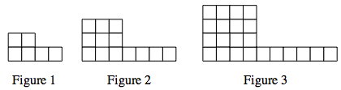

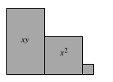
- 3-59. Write an expression that represents the perimeter of the shape built with algebra tiles at right. Then find the perimeter if x = 3 units and y = 7 units.

- 3-60. Simplify the following expressions by combining like terms.
  - y + 2x − 3+ 4x ² + 3x − 5y

  - 2x − 6x ² + 9 − 1 − x − 3x

  - 2y ² + 30x − 5y ² + 4x − 4y – y

  - −10 + 3xy − 3xy + y ² +10 − y ²

