- 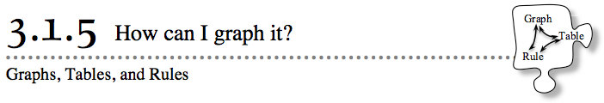In Lesson 3.1.4, you practiced setting up the correct axes to graph data from a table. Today you will graph a rule by first making a table, and then by plotting the points from your table on a graph. You will also continue to find patterns in tables and graphs.
- 3-42. SILENT BOARD GAME
- Your teacher will put an incomplete x → y table on the board. Try to find the pattern (rule) that gets each y-value from its x-value. Find and write the rule for the pattern you find.
- 3-43. GOOD TIPPER
- Mr. Wallis needs your help. He is planning to take his new girlfriend out to dinner. He will, of course, leave a tip for the wait staff at the end of the meal. He decides to create a “tip table” that will help him quickly determine how much tip to leave.
  - What are reasonable values of x? Mr. Wallis needs a tip table that will help him quickly determine a tip for a bill that may occur after a nice dinner for two. Discuss this with your team and then choose eight values for x.
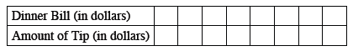
  - Mr. Wallis is planning to leave a 15% tip. That means that for a bill of $10, he would leave a $1.50 tip. Determine the tip for all of the values in your table from part (a). This is Mr. Wallis’s tip table.

  - Use the tip table to estimate the tip quickly if the bill is $36. What if the bill is $52.48?

  - Mr. Wallis is worried that he may not be able to estimate very quickly if he uses his table for unusual amounts, such as $52.48. He would like a graph to help him determine a 15% tip for all possible dollar amounts between $10 and $100. With your team, determine how to set up axes. Then graph the points from the tip table. Use the questions below to help guide your discussion.
    - Should the tip be graphed on the x-axis or the y-axis? Read the Math Notes box for this lesson about dependent variables and independent variables to help you decide.
    - Which quadrants are useful for this graph? Why?
    - What are the greatest and smallest values of x and y that must fit on the graph? How can you scale your axes to create the most effective graph for Mr. Wallis?
  - Use your tip graph from part (d) to test your estimations in part (c). Which representation (table or graph) helped to find the most accurate tip? Which was easiest to use? Explain.
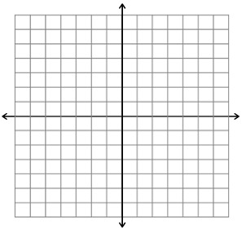
3-44. ONE OF THESE POINTS IS NOT LIKE THE OTHERS, Part One
  - Plot and connect the points in the table below.

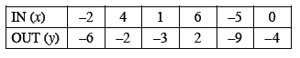
  - Identify the point that does not appear to fit the pattern.
  - Correct the point found in part (b) above so it fits the pattern.
3-45. Complete the table below for the rule y = $\frac{1}{2}$x + 6 .

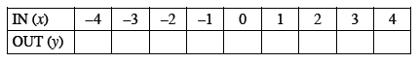
Graph and connect the points from your table on graph paper. Remember to label the graph with its rule. Does the point (10, 12) lie on this graph? How can you tell?

