Name:
Date:
Lesson 3.1.5 Homework
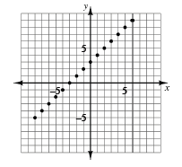
- 3-46. Create an x → y table using at least eight points from the graph at the right. Write the rule for the pattern in the table.

- 3-47. For each rule below, make a table of x- and y-values. Then graph and connect the points from your table on graph paper using an appropriate scale. Label each graph with its equation.
  - y = −2x + 7
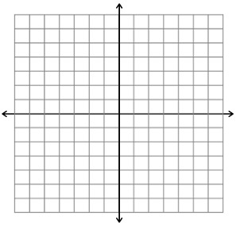

  - y = 11x

3-48. WHICH IS GREATER?
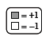
Write the algebraic expressions shown below. Use “legal” simplification moves to determine which expression in the Expression Comparison Mat is greater.
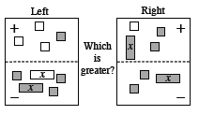
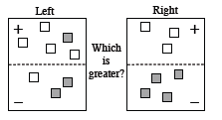

3-49. Simplify each expression.
- $\frac{2}{3}(0.8)$

- $\frac{4}{3}×\frac{3}{7}$

- $-\frac{5}{6}×\frac{4}{7}$

- $-\frac{4}{5}×-\left(1\frac{1}{3}\right)$
3-50. For the following equations, simplify and solve for the variable. Record your work.
  - 2x − 7 = −2x + 1

  - −2x − 5 = −4x + 2

