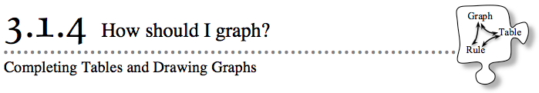
- In Lesson 3.1.3, you used a graphing tool to represent all of the x → ypairs that follow a particular rule. Today you will learn how to make your own graphs for rules and how to recognize patterns in graphs.
- 3-33. CLASS GRAPH
- Your teacher will give your team some x-values. For each x-value, calculate the corresponding y-value that fits the rule y = −5x + 12. Then mark the point you have calculated on the class graph.

- 3-34. Use the rule y = 2x + 1 to complete parts (a) through (c) below.
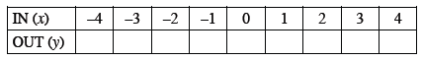
  - Make a table like the one below and use the rule provided above to complete it.

  - Examine the numbers in the table. What are the greatest x- and y-values in the table? What are the smallest x- and y-values? Use this information to set up x- and y-axes that are scaled appropriately.

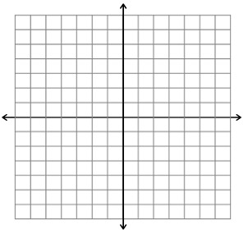
  - Plot and connect the points on a graph. Be sure to label your axes and write numbers to indicate scale.

3-35. Calculate the y-values for the rule y = −3x + 1 and complete the table below.
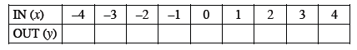
  - Examine the x- and y-values in the table. Is it possible to use the same set of axes as problem 3-34? If so, graph and connect these points on the axes from problem 3-34. If not, plot and connect the points on a new set of axes.
  - What does your graph look like? Describe the result.

  - How is this graph similar to the graph in problem 3-34? How is it different?

3-36. Calculate the y-values for the rule y = x² and complete the table below.
  - Examine the x- and y-values in the table. Use this information to set up a new set of x- and y-axes that are scaled appropriately. Plot and connect the points on your graph, and then label your graph with its rule.

  - This graph is an example of a parabola. Read about parabolas in the Math Notes box below. Where is the vertex of the parabola you graphed in part (a)?

