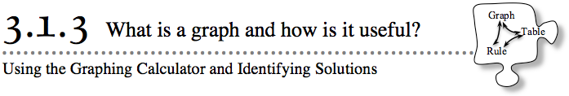

- 3-21.
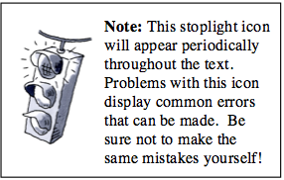
- If necessary, re-enter your data from the “Big C’s” pattern into your graphing calculator. Re-enter the rule you found in problem 3-18 and graph the data and rule in the same window.
- For the following problems, justify your conclusions with the graph, the rule, and the figure (whenever practical). Your teacher may ask your team to present your solution to one of these problems. Be sure to justify your ideas using all three representations.
  - Frangelica thinks that Figure 6 in the “Big C’s” pattern has 40 tiles. Decide with your team whether she is correct and justify your answer by using the rule, drawing Figure 6, and adding the point to your graph of the data. Be prepared to show these three different ways to justify your conclusion.

  - Giovanni thinks that the point (16, 99) belongs in the table for the “Big C’s” pattern. Decide with your team whether he is correct, and justify your conclusion by examining the graph and the rule.

  - Jeremiah is excited because he has found another rule for the “Big Cs” pattern! He thinks that y = x + 8 also works. Prove or disprove Jeremiah’s claim. Be prepared to convince the class that your conclusion is correct.

  - LaTanya has been thinking hard and has found another rule for the same pattern! She is sure that y = 3(2x + 1) is also correct. Prove or disprove LaTanya's position in as many ways as you can.

3-22. Look back at the prediction you made in problem 3-18 for Figure 100 in the “Big C’s” pattern. Decide now if your prediction was correct, and be ready to defend your position with all of the math tools you have.

