Name:
Date:
Lesson 3.1.3 (Pt. 2) Homework
- 3-28. Use your pattern skills to complete the table.
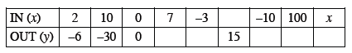

  - Explain in words what is done to the input value, x, to produce the output value, y.

  - Write the process you described in part (a) in algebraic symbols.

3-29. For the following equations, draw a picture of the tiles on an Equation Mat, use “legal” moves to simplify, and solve for the variable. Record your work.

  - −3x + 7 = −x − 1
  - 1 − 2p + 5 = 4p + 6

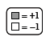

3-30. Write the equation represented in the equation mat below.
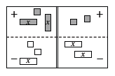

  - Simplify as much as possible and solve for x.

  - Evaluate both the left side and the right side using your solution from part (a). Remember that if your solution is correct, both sides should have the same value.

3-31. Tickets to 50 home baseball games would cost $1137.50. How much would it cost to get tickets for all 81 home games? How many games could you go to for $728? What is the cost of one game?

3-32. Combine like terms in each part below.
  - Liha has three x² -tiles, two x-tiles, and eight unit tiles, while Makulata has five x²-tiles and two unit tiles. At the end of class, they put their pieces together to give to Ms. Singh. Write an algebraic expression for each student's tiles and find the sum of their pieces.

  - Simplify the expression 4x + 6x² − 11x + 2 + x² − 19.

  - Write the length of the line below as a sum. Then combine like terms.
