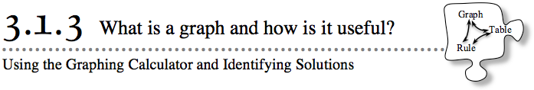
- In the last two lessons, you examined several patterns. You learned how to represent the patterns in a table and with a rule. For the next few days, you will learn a powerful new way to represent a pattern and make predictions.
- 3-18. On the Lesson 3.1.3 Resource Page provided by your teacher, find the “Big C’s” pattern shown at right.
  - Draw Figure 0 and Figure 4 on the grid provided on the resource page.
  - On the resource page, represent the number of tiles in each figure with:
    - An x → y table.
    - An algebraic rule.
    - A graph.
  - How many tiles will be in Figure 5? Justify your answer in at least two different ways.
  - What will Figure 100 look like? How many tiles will it have? How can you be sure?
3-19. Use the graphing technology provided by your teacher to analyze the pattern further and make predictions.
  - Enter the information from your x → y table for problem 3-18 into your graphing calculator. Then plot the points using a window of your choice. What do you notice?
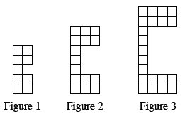
  - Find another x → y pair that you think belongs in your table. Use your graphing calculator to plot the point. Does it look correct? How can you tell?

  - Imagine that you made up 20 new x → y pairs. Where do you think their points would lie if you added them to the graph?

3-20. In the same window that contains the data points, graph the algebraic equation for the pattern from problem 3-18.
  - What do you notice? Why did that happen?

  - Charles wonders about connecting the points of the “Big C’s” data. When the points are connected with an unbroken line or curve, the graph is called continuous. If the graph of the tile pattern is continuous, what does that suggest about the tile pattern? Explain.

  - Jessica prefers to keep the graph of the tile-pattern data as separate points. This is called a discrete graph. Why might a discrete graph be appropriate for this data?

