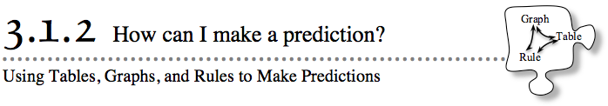
- In Lesson 3.1.1, you wrote rules for patterns found in x → y tables. In this lesson, you will focus on using variables to write algebraic rules for patterns and contextual situations. You will use a graph to help predict the output for fractional x-values and will then use a rule to predict the output when the input is too large and does not appear on the graph.
- 3-9. SILENT BOARD GAME
- During Lesson 3.1.1, you created written rules for patterns that had no tiles or numbers. You will now write algebraic rules using a table of jumbled in/out numbers. Focus on finding patterns and writing rules as you play the Silent Board Game. Your teacher will put an incomplete x → y table on the board. Study the input and output values and look for a pattern. Then write the rule in words and symbols that finds each y-value from its x-value.
- 3-10. JOHN'S GIANT REDWOOD, Part One
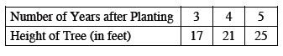
- John found the data in the table below about his favorite redwood tree. He wondered if he could use it to predict the height of the tree at other points of time. Consider this as you analyze the data and answer the questions below. Be ready to share and justify your answers with the class.

  - How much did the tree grow each year?

  - How tall was the tree 2 years after it was planted? What about 7 years after it was planted? How do you know?

  - How tall was the tree the year it was planted?

  - Estimate the height of the tree 50 years after it was planted. How did you make your prediction?
3-11. John decided to find out more about his favorite redwood tree by graphing the data.
  - On the Lesson 3.1.2B Resource Page provided by your teacher, plot the points that represent the height of the tree over time.
  - What does the graph look like? Does the graph represent a proportional relationship? Justify your answer.

  - Does it make sense to connect the points? Explain your thinking.

  - According to the graph, what was the height of the tree 1.5 years after it was planted?

  - Can you use your graph to predict the height of the redwood tree 20 years after it was planted? Why or why not?

3-12. John is still not satisfied. He wants to be able to predict the height of the tree at any time after it was planted.
  - Find John’s table on your resource page and extend it to include the height of the tree in the 0th year, 1st year, 2nd year, and 6th year.
  - If you have not done so already, use the ideas from the Silent Board Game to write an algebraic rule for the data in your table. Be sure to work with your team and check that the rule works for all of the data.

  - Use your rule to check your prediction in part (c) of problem 3-10 for how tall the tree will be in its 50th year. How close was your prediction?

