Name:
Date:
Lesson 3.1.2 Homework
- 3-13. Copy and use your pattern skills to complete the table below.
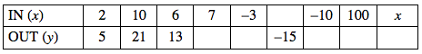
  - Explain in words what is being done to the input value, x, to produce the output value, y.

  - Write the process you described in part (a) in algebraic symbols.

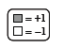
3-14. Write the equation represented in each diagram below on your paper. For each part, simplify as much as possible and then solve for x. Be sure to record your work on your paper.
- 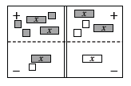
- 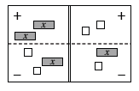
3-15. Evaluate the following expressions given the values below.

  - ab + bc + ac for a = 2, b = 5, and c = 3

  - 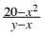 for x = −2 and y = 6

3-16. Use the order of operations to simplify the following expressions.

  - 5 − 2 · 3²

  - (−2)²

  - 18 ÷ 3 · 6

  - −2²

  - (5 − 3)(5 + 3)

  - 24 · ÷ (−2)

  - Why are your answers for parts (b) and (d) different?

3-17. Mrs. Swanson gives out only one type of candy for Halloween. The local discount store sells six pounds of butterscotch candies for $7.50. Use proportional reasoning to answer the questions below. Be sure to explain your answer and organize your reasoning.
  - What is the cost of 18 pounds of butterscotch candies?

  - What is the cost of 10 pounds of butterscotch candies?

  - What is the unit rate for butterscotch candies?

