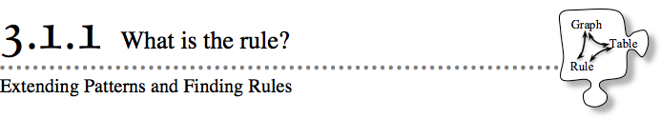
- You have been learning how to work with variables and how to find values for variables in equations. In this section, you will learn how to extend patterns and how to generalize your pattern with a rule.
- 3-1. Some people describe mathematics as “the study of patterns.” For each tile pattern below, draw Figure 1 and Figure 5 on graph paper. First try it individually, and then consult with your team. What does Figure 100 look like? Explain how you know.
  - 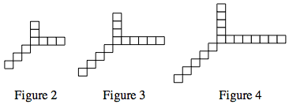

  - 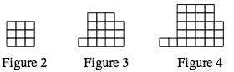

3-2. FINDING RULES FROM TABLES
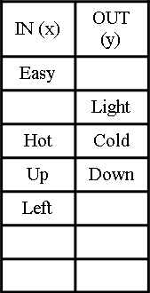
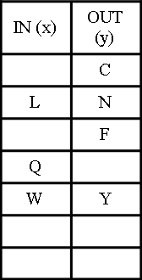
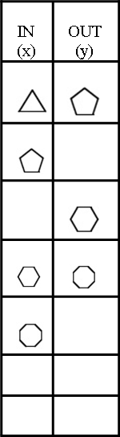
- How can you describe the rule that governs a pattern or table? As a class, find the pattern, fill in the missing parts, and extend each table with at least two more x → y pairs that fit the pattern. Then generalize the pattern’s rule in words.

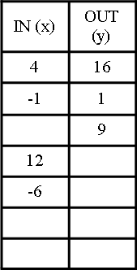
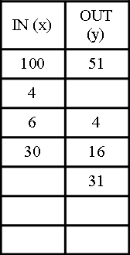
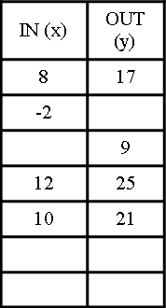

3-3. For each x → y table given, find the pattern and fill in the missing entries. Then write the rule for the pattern in words. Be sure to share your thinking with your teammates.
