Name:
Date:
Lesson 3.1.1 Homework
3-4. For each x → y table given, copy the table, find the pattern and fill in the missing entries. Then write the rule for the pattern in words.
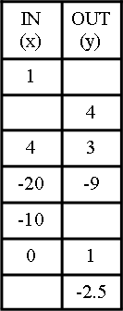
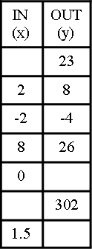
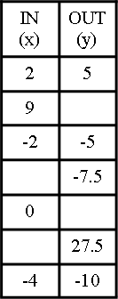

3-5. At the fair, Kate found a strange machine with a sign on it labeled, “Enter a number.” When she pushed the number 15, the machine displayed 9. When she entered 23, the machine displayed 17. Perplexed, she tried 100, and the machine displayed 94.
  - What is the machine doing?

  - What would the machine display if she entered 77?

3-6. Ms. Nguyen needs to separate $385 into three parts to pay some debts. The second part must be five times as large as the first part. The third part must be $35 more than the first part. How much money must be in each part? Write and solve an equation.

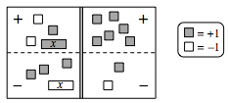
3-7. On your paper, write the equation represented on the Equation Mat below. Simplify as much as possible and then solve for x.

3-8. GO GOLDEN GOPHERS!
The graph below describes the distance two cars have traveled after leaving a football game at the University of Minnesota.
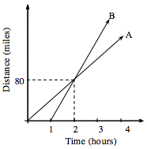
  - Which car was traveling faster? How can you tell?

  - The lines cross at (2, 80). What does this point represent?

  - Assuming that Car A continued to travel at a constant rate, how far did Car A travel in the first 4 hours?

