Name:
Date:
Lesson 2.1.9 Homework
- 2-85. Ling wants to save $87 for tickets to a rock concert. If she has $23 now and will save $4 per week, how long will it take her to get enough money to buy the tickets? Define a variable and then write and solve an equation. (Use the 5-D Process to help you, if needed.) Write your solution as a sentence.

- 2-86. When you want to convince someone that 8x + (2x − 3) is equivalent to (8x + 2x) − 3, you can support your claim with the Associative Property of Addition.
Determine if the following statements are true or false. If true, justify your conclusion by stating the appropriate algebraic property. If false, explain how you know.

  - (81)(38) = (38)(81)

  - 27 + 0 = 27

  - 3 − 5 = 5 – 3

  - 19.4 · 1 = 19.4

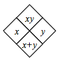
2-87. Complete each of the Diamond Problems below. The pattern used in the Diamond Problems is shown at right.
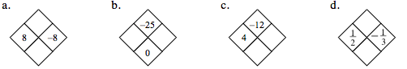
2-88. Ferroza can buy a 24-ounce bag of ferret food for $1.19, or she can buy a 36-ounce bag for $2.89. Which is the better deal? Justify your conclusion.

2-89. This problem is a checkpoint for evaluating expressions and using the Order of Operations. It will be referred to as Checkpoint 2.
Evaluate each expression if x = −2, y = −3, and z = 5.

  - 2x + 3y + z

  - x – y

  - $2\left(\frac{x+y}{z}\right)$

  - 3x² − 2x + 1

  - 3y(x + x² − y)

  - $\frac{-z^{2}(1-2x)}{y-x}$

