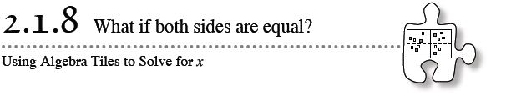
- Can you always tell whether one algebraic expression is greater than another? In this section, you will continue to practice the different simplification strategies you have learned so far to compare two expressions and see which one is greater. However, sometimes you do not have enough information about the expressions. When both sides of an equation are equal, you can learn even more about x.
- 2-72. WHICH IS GREATER?
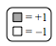
- Build each expression represented below with the tiles provided by your teacher. Use “legal” simplification moves to determine which expression is greater, if possible. If it is not possible to determine which expression is greater, explain why it is impossible. Be sure to record your work on your paper.
  - 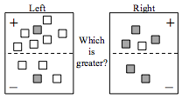

  - Which is greater: x + 1 − (1 − 2x) or 3 + x − 1 − (x − 4)?

2-73. WHAT IF BOTH SIDES ARE EQUAL?
If the number 5 is compared to the number 7, then it is clear that 7 is greater. However, what if you compare x with 7? In this case, x could be smaller, larger, or equal to 7.
Examine the Expression Comparison Mat below.
- 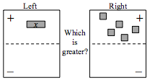
  - If the left expression is smaller than the right expression, what does that tell you about the value of x?
  - If the left expression is greater than the right expression, what does that tell you about the value of x?
  - What if the left expression is equal to the right expression? What does x have to be for the two expressions to be equal?
2-74. SOLVING FOR X
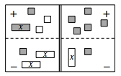
In later courses, you will learn more about situations like parts (a) and (b) in the preceding problem, called “inequalities.” For now, to learn more about x, assume that the left expression and the right expression are equal. The two expressions will be brought together on one mat to create an Equation Mat, as shown in the figure below. The double line down the center of an Equation Mat represents the word “equals.” It is a wall that separates the left side of an equation from the right side.
  - Build the equation represented by the Equation Mat at right using algebra tiles. Simplify as much as possible and then solve for x. Be sure to record your work.
  - Build the equation 2x − 5 = −1 + 5x + 2 using your tiles by placing 2x − 5 on the left side and −1 + 5x + 2 on the right side. Then use your simplification skills to simplify this equation as much as possible so that x is alone on one side of the equation. Use the fact that both sides are equal to solve for x. Record your work.
2-75. Now apply the solving skill from problem 2-74 by building, simplifying, and solving each equation below for x. Record your work.
  - 3x − 7 = 2
  - 1 + 2x − x = x − 5 + x
  - 3 − 2x = 2x − 5
  - 3 + 2x − (x + 1) = 3x − 6
  - −(x + 3 − x) = 2x − 7
  - −4 + 2x + 2 = x + 1 + x

