Name:
Date:
Lesson 2.1.8 Homework
- 2-76. Translate the Equation Mat at right into an equation. Remember that the double line represents “equals.” 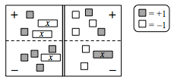
- 2-77. Decide if each statement below is true or false. Explain how you know and name any properties you use. Refer to the Math Notes boxes in this lesson and in Lessons 2.1.5 and 2.1.7 to help you.

  - −19 + 7 = −7 + 19

  - $\frac{4}{5}$ · 1 = $\frac{4}{5}$

  - $\frac{3}{2}$ · $\frac{2}{3}$ = 1

  - 5 · 7 − 5 · $\frac{1}{5}$ = 34

2-78. Simplify each expression below as much as possible.

  - 3y − y + 5x + 3 − 7x

  - −1 − (−5x) − 2x + 2x² + 7

  - 6x + 2 − 1 − 4x − 3 − 2x + 2

2-79. Plot the points (0, 0), (3, 2), and (6, 4) on graph paper. Then draw a line through the points. Name the coordinates of three more points on the same line.
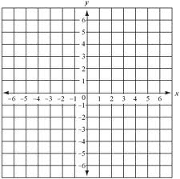

2-80. Evaluate the expressions below for the given values.

  - 6m + 2n² for m = 7 and n = 3

  - for x = −18
  - for x = 10

  - (k − 3)(k + 2) for k = 1

