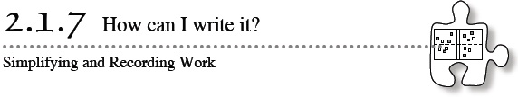
- Today you will continue to compare expressions as you strengthen your simplification strategies. At the same time, you will work with your class to find ways to record your work so that another student can follow your strategies.
- 2-63. Use algebra tiles to build the expressions below on an Expression Comparison Mat. Use “legal” simplification moves to determine which expression is greater, if possible. If it is not possible to tell which expression is greater, explain why.
  - Which is greater: 3x − (2 − x) + 1 or −5 + 4x + 4?
  - Which is greater: 2x² − 2x + 6 − (−3x) or −(3 − 2x²) + 5 + 2x?
  - Which is greater: −1 + 6y − 2 + 4x − 2y or x + 5y − (−2 + y) + 3x − 6?
2-64. RECORDING YOUR WORK
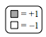
- 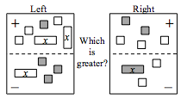
Although using algebra tiles can make some things easier because you can “see” and “touch” the math, it can be difficult to remember what you did to solve a problem unless you take good notes.

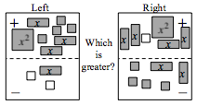
2-65. While Athena was comparing the expressions shown at right, she was called out of the classroom. When her teammates needed help, they looked at her paper and saw the work shown below. Unfortunately, she had forgotten to explain her simplification steps.
Can you help them figure out what Athena did to get each new set of expressions?
Left Expression | Right Expression | Explanation
3x + 4 − x − (−2) + x² | −1 + x² + 4x − (4 + 2x) | Original expressions
3x + 4 − x − (− 2) | −1 + 4x − (4 + 2x)
3x + 4 − x + 2 | − 1 + 4x − 4 − 2x
2x + 6 | 2x − 5
6 | −5
Because 6 > −5, the left side is greater.
2-66. For each pair of expressions below, determine which is greater, carefully recording your steps as you go. If you cannot tell which expression is greater, state, “Not enough information.” Make sure that you record your result after each type of simplification. For example, if you flip all of the tiles from the “–” region to the “+” region, record the resulting expression and indicate what you did using either words or symbols. Be ready to share your work with the class.

a.

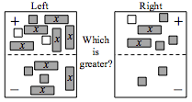
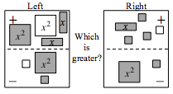
  - Which is greater: 5 − (2y − 4) − 2 or −y − (1 + y) + 4?
  - Which is greater: 3xy + 9 − 4x − 7 + x or −2x + 3xy − (x − 2)?

