Name:
Date:
Lesson 2.1.7 Homework
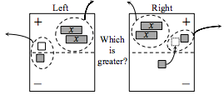
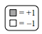
- 2-67. Sylvia simplified the expressions on the expression comparison mat shown below. Some of her work is shown. Are all of her moves “legal”? Explain.

- 2-68. Read the Math Notes boxes in this lesson and for Lesson 2.1.5. Then examine the work below that shows one way to simplify the expression 3x+ 8 + (x +10). Decide which property was used for each step.
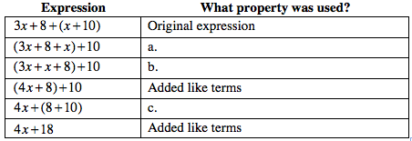
- 2-69. Examine the tile pattern at below.
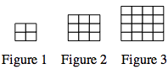
  - On graph paper, draw Figures 4 and 5.
  - What would Figure 10 look like? How many tiles would it have? What about Figure 100?

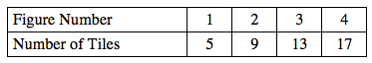
  - Cami has a different tile pattern. She decided to represent the number of tiles of her pattern in a table, as shown below. Can you use the table to predict how many tiles would be in Figure 5 of her tile pattern? How many tiles would Figure 8 have? Explain how you know.

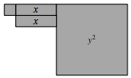
2-70. Examine the shape made with algebra tiles below.
  - Write an expression that represents the perimeter of the shape. Then evaluate your expression for x = 6 and y = 10 units.

  - Write an expression that represents the area of the shape. What is the area if x = 6 and y = 10 units?
2-71. Match each result to an answer in the right-hand column.
a. −3 + 16 − (−5) | 1. −16
b. (3 − 5)(6 + 2) | 2. 327
c. 17(−23) + 2 | 3. 0.5
d. 5 − (3 − 17)(−2 + 25) | 4. 18
e. (−4)(−2.25)(−10) | 5. −90
f. −1.5 − 2.25 − (−4.5) | 6. 0.75
g. | 7. −389

