- Can you always tell whether one algebraic expression is greater than another? In this lesson, you will compare the values of two expressions, practicing the different simplification strategies you have learned so far.
- 2-56. WHICH IS GREATER?
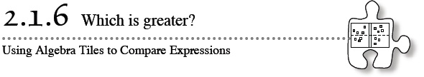
- Write an algebraic expression for each side of the Expression Comparison Mats given below. Use the “legal” simplification moves you worked with in Lesson 2.1.5 to determine which expression on the Expression Comparison Mat is greater.


   