Name:
Date:
Lesson 2.1.6 Homework
- 2-58. WHICH IS GREATER?
For each Expression Comparison Mat below, simplify and determine which side is greater.
a. 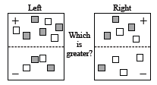 | b. 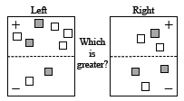
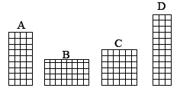
- 2-59. Cairo wants to create a graph that represents the heights and bases of all rectangles that have an area of 36 square units. He started by drawing the rectangles A, B, C, and D below. Examine the dimensions (length and width) of each rectangle.

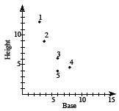
  - Match the letter of each rectangle above with a point on the graph. Which point is not matched?

  - What are the base, height, and area for the unmatched point?

  - Why should the unmatched point not be on Cairo’s graph?

  - Find the dimensions of three more rectangles that have areas of 36 square units. At least one of your examples should have dimensions that are not integers. Place a new point on the graph for each new rectangle you find.

  - Connect all of the points representing an area of 36 square units. Describe the resulting graph.

2-60. Use substitution to find y.

  - y = 3 + 8.5x, when x = −4

  - y = x − 15, when x = 2.65

  - y = (x − 5)(x + 2), when x = 3

  - y + 6.2x = −13, when x = −4

2-61. One of Teddy’s jobs at home is to pump gas for his family’s sedan and truck. When he fills up the sedan with 12 gallons of gas, he notices that it costs him $50.28.
  - How much does one gallon of gas cost? This is also called the unit rate. Explain how you found your answer.

  - How much will it cost him to fill up the truck if it needs 25 gallons of gas? Show your work.

  - When Teddy filled up the tank on his moped, it cost $5.03. How much gas did his moped need? Explain how you know.

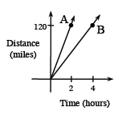
2-62. The graph below shows distances traveled by Car A and Car B. Car A is represented by the line containing point A, and Car B is represented by the line containing point B. Use the graph to answer the following questions.
  - Which car is traveling faster? How can you tell?

  - Find the coordinates of point A and point B.

  - How fast did Car A travel (in miles per hour)? How fast did Car B travel?

  - Does the distance Car A has traveled vary directly with the time? Why or why not?

