- Which is greater: 58 or 62? That question might seem easy, because the numbers are ready to be compared. However, if you are asked which is greater, 2x + 8 − x − 3 or 6 + x + 1, the answer is not so obvious! In this lesson, you and your teammates will investigate how to compare two algebraic expressions and decide whether one is greater.
- 2-46. For each expression below:
  - Use an expression mat to build the expression.
  - Find a different way to represent the same expression using tiles.
  - 7x − 3
  - −(−2x + 6) + 3x
2-47. COMPARING EXPRESSIONS
Two expressions can be represented at the same time using an Expression Comparison Mat. The Expression Comparison Mat puts two Expression Mats side-by-side so you can compare them and see which one is greater. For example, in the picture at right, the expression on the left represents –3, while the expression on the right represents –2. Since −2 > −3, the expression on the right is greater.
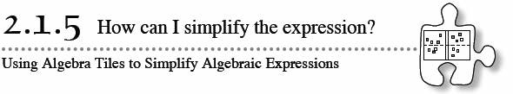
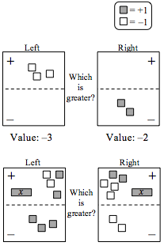
Build the Expression Comparison Mat shown at right. Write an expression representing each side of the Expression Mat.
  - Can you simplify each of the expressions so that fewer tiles are used? Develop a method to simplify both sides of the Expression Comparison Mats. Why does it work? Be prepared to justify your method to the class.
  - Which side of the Expression Comparison Mat do you think is greater (has the largest value)? Agree on an answer as a team. Make sure each person in your team is ready to justify your conclusion to the class.

2-48. As Karl simplified some algebraic expressions, he recorded his work on the diagrams below.
  - Explain in writing what he did to each Expression Comparison Mat on the left to get the Expression Comparison Mat on the right.
  - If necessary, simplify further to determine which Expression Mat is greater. How can you tell if your final answer is correct?
