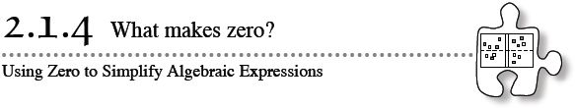
- 2-34. LIKELY STORY!
Imagine the following situations:
  - Julie baby-sits for her neighbor’s baby and stuffs the $15 she earned into her purse. When she gets home, the $15 is nowhere to be found. It must have fallen out of her purse.
  - The Burton Pumas football team completes a pass and gains 12 yards. But on the very next play, the quarterback holds onto the ball too long and gets sacked, losing 12 yards.
  - Rolando is at the beach. He digs a hole in the sand and places the sand he removes in a pile next to his hole. Someone comes along and pushes the pile back into the hole.
What do each of these situations have in common? Can you represent each of them using symbols? How?
- 2-35. How can you represent zero with tiles on an Expression Mat? With your team, try to find at least two different ways to do this (and more if you can). Be ready to share your ideas with the class.

- 2-36. Gretchen used seven algebra tiles to build the expression shown at right.
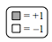
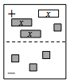
  - Build this collection of tiles on your own Expression Mat and write its value (“flap”).
  - Represent this same value three different ways, each time using a different number of tiles. Be ready to share your representations with the class.
2-37. Build each expression below so that your representation does not match those of your teammates. Once your team is convinced that together you have found four different, valid representations, sketch (“flap”) your representation on your paper and be ready to share your answer with the class.
  - −3x + 5 + y
  - −(−2y + 1)
  - 2x − (x − 4)
2-38. Write the algebraic expression shown on each Expression Mat below. Build the model and then simplify the expression by removing as many tiles as you can without changing the value of the expression. Finally, write the simplified algebraic expression.
a. | b.
2-39. Simplify each of the following expressions by building it on your Expression Mat and removing zeros. Your teacher will give you instructions about how to represent your work on your paper.
  - 3x − (2x + 4)
  - 7 − (4y − 3) + 2y − 4

