Name:
Date:
Lesson 2.1.4 Homework
- 2-41. Can zero be represented by any number of tiles? Using only the unit tiles (in other words, only the 1 and –1 tiles), determine whether you can represent zero on an Expression Mat with the number of tiles below. If you can, draw an Expression Mat demonstrating that it is possible. If it is not possible, explain why not.

  - 2 tiles
  - 6 tiles
  - 3 tiles

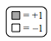
2-42. Write and simplify the algebraic expression shown in each Expression Mat below.
a. 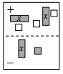 | b. 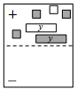 | c. 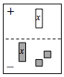
2-43. Read the Math Notes box for this lesson. Then evaluate each expression below.

  - For y = 2x +3 when x = 4, what does y equal?

  - For a = 4 − 5c when c = $-\frac{1}{2 }$, what does a equal?

  - For n = 3d² − 1 when d = −5, what does n equal?

  - For v = −4(r − 2) when r = −1, what does v equal?

  - For 3 + k = t when t = 14, what does k equal?

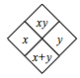
2-44. Complete each of the Diamond Problems below. The pattern used in the Diamond Problems is shown below.
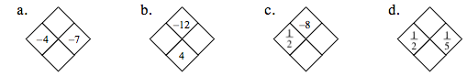

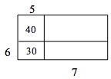
2-45. Find the perimeter of the entire rectangle shown at right (that is, the length of the outside boundary of the figure). Notice that the areas of two of the parts have been labeled inside the rectangle. Also find the total area. Remember to show all work leading to your solution.

